**HOME NETWORK TOPLOGY:**

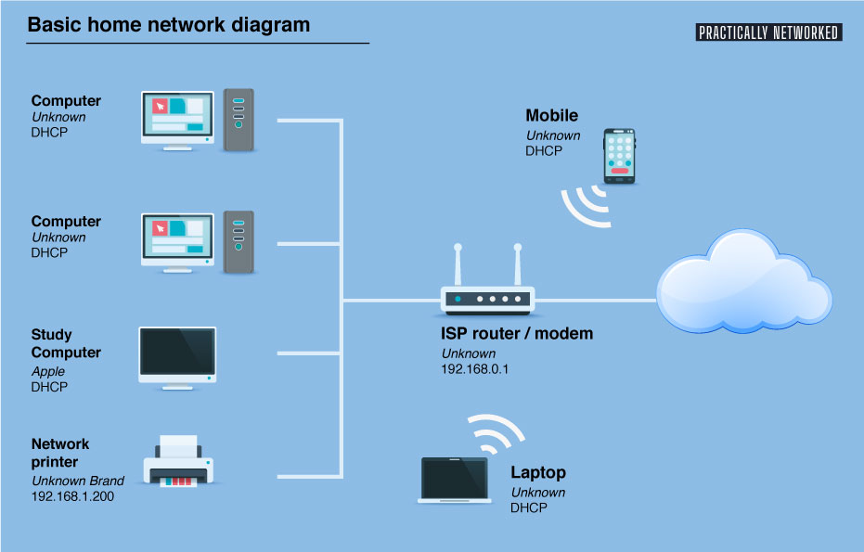

* A home network topology describes how devices like computers, smartphones, and printers are connected within a household to share internet access and resources. Common topologies include star, bus, and mesh, with star being the most popular for home networks. These arrangements influence network performance, scalability, and security.

Here's a more detailed look:

**1. Star Topology:**

**Description:** All devices connect to a central hub or switch, which acts as a central point for communication.

**Advantages:** Easy to troubleshoot, scalable, and reliable, as a single device failure doesn't affect the entire network.

**Disadvantages:** If the central hub/switch fails, the entire network goes down.

**2. Bus Topology:**

**Description:** All devices are connected to a single cable or bus.

**Advantages:** Simple and inexpensive to set up.

**Disadvantages:** Can become congested with traffic, and if the main cable is damaged, the entire network is affected.

**3. Mesh Topology:**

**Description:** Each device is connected to multiple other devices, creating a network of interconnected nodes.

**Advantages:** Highly reliable and robust, as data can be routed through multiple paths if one connection fails.

**Disadvantages:** More complex to set up and manage than star or bus topologies.

Other Considerations for Home Networks:

**Wired vs. Wireless:**

Home networks can use wired connections (Ethernet cables) or wireless connections (Wi-Fi).

**Access Points:**

Wireless networks utilize access points to extend the range of the Wi-Fi signal.

**Modems and Routers:**

A modem connects to the internet service provider (ISP), and a router manages traffic flow within the home network.

In essence, the topology of a home network dictates how devices communicate and share resources, influencing factors like speed, reliability, and ease of management.